**Project 2: Bowling Simulator Continued**

**Goal:** Create a bowling simulator capable of using the Nintendo Switch Joycon input to simulate bowling.

**Description:**

The bowling game will have the player choose a starting position along the x-axis of the OpenGL view volume shown below. The lane is located down the negative y-axis. Next, the player will choose to input an initial velocity along the y and x-axis. Assume there is no friction on the lane. The Joycons output of angular velocity in degrees per second will be used to measure initial velocity along x-axis. Measuring the initial velocity along the y-axis is trickier. Both the initial angular velocity along the x-axis, and acceleration along the y-axis values can be used.

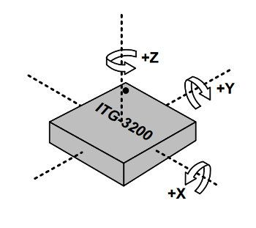

**Theme:** 2000s bowling lane – think Justin Bieber Baby

* Blue Point light, spotlight on pins, red light attenuating with distance

**Lighting**

1. Point lights:
   1. White light over pins attenuates with distance.
      1. Adjustable with button input
   2. Blue light illuminates’ lanes
2. Red spotlight highlights ball and track

**Objects:**

1. Bowling pins
   1. White
   2. Painted stripe
2. Bowling Ball
   1. Material:
3. Alley Lane
   1. Material:
4. Pinsetter Unit: https://www.youtube.com/watch?v=Iod6uwUGM2E
   1. Setting Table: bars move with table. No rotations for simplicity

* 1. Sweep Wagon: Sweep release assembly lowers tray. Sweep crank arm slides tray across Sweep. Assembly closes, pulling up tray.
     1. Material: https://stock.adobe.com/search?k=bowling%20lane%20wood

**Classes:**

Bowling ball

* Position
* Velocity

Bowing Pin

* Position
* Velocity

**Specifications:**

The game must also support keyboard inputs. The games will simulate this online game form duckster.com: <https://www.ducksters.com/games/bowling.php>.

1. The bowling ball will initialize at the middle of the bowling lane. Directional arrows will point to the left and right of the ball. The player will first use the left and right keys to translate the ball to their intended starting position on the lane.
2. After clicking the mouse, the directional arrows will disappear, and a power bar will appear on the screen. The bar will move up and down at a regular speed until a mouse click is received.
3. Upon mouse click input, the power bar will disappear, and an angular velocity arrow will appear. The velocity arrow will rotate left-then-right at a regular angular velocity until a mouse-click is received.
4. After a click, the angular velocity arrow ill disappears, and the bowling ball will move with a velocity along the x and y axis.
5. Users can alternate between the bowling perspective and a flying camera by pressing the space bar.

* Physics: Only the bowling ball interacts with the pins. The Pins have cylindrical hitboxes slightly smaller than the pin’s radius.
* Sweep and setter move independently of pinsetter unit.